**LETSUPGRADE LINUX ADMINSTRATION**

**DAY 8 ASSIGNMENT**

**Assignment 0**

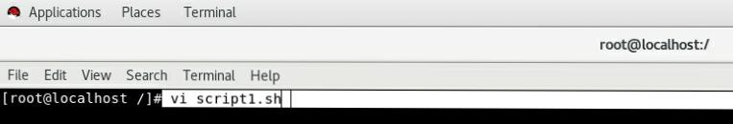Opening Script File

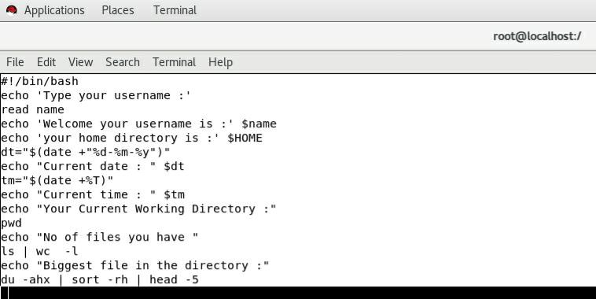Doing Scripting

Output 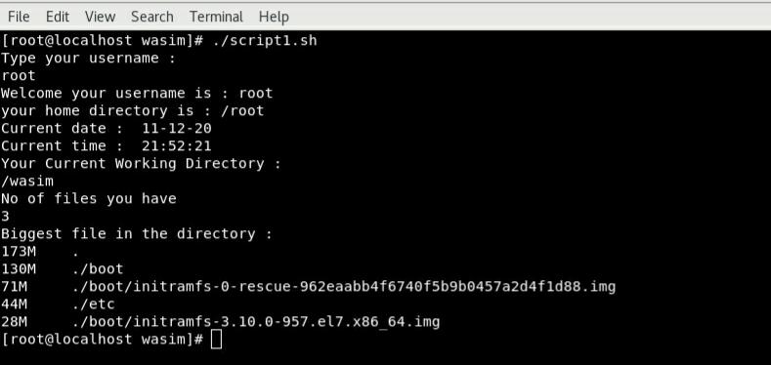

**Assignment 1**

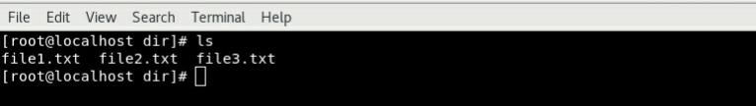Creating Files

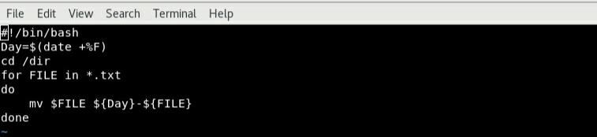Scripting

Output

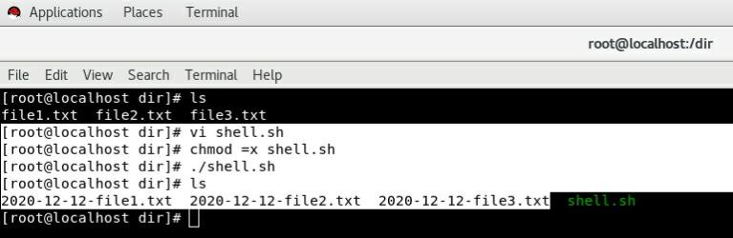

**Assignment 2**

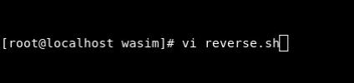Opening Script File

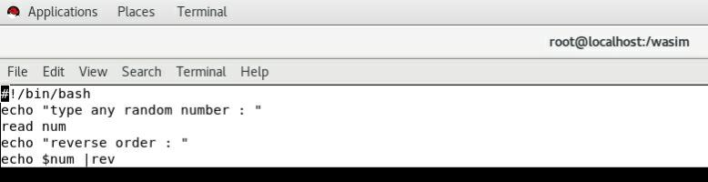Scripting

Output

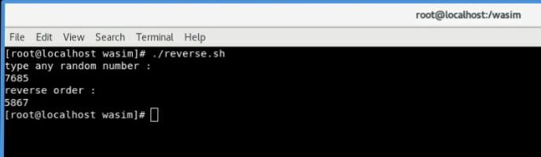

**Assignment 3**

**Here I Have Used Termux Which Is An Android Application For Scripting**

Opening The File

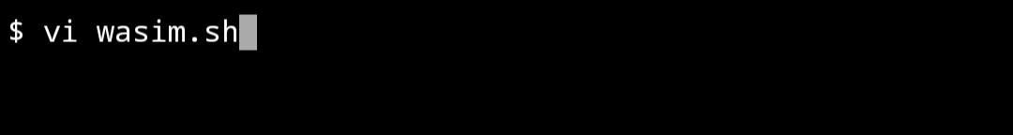

Scripting

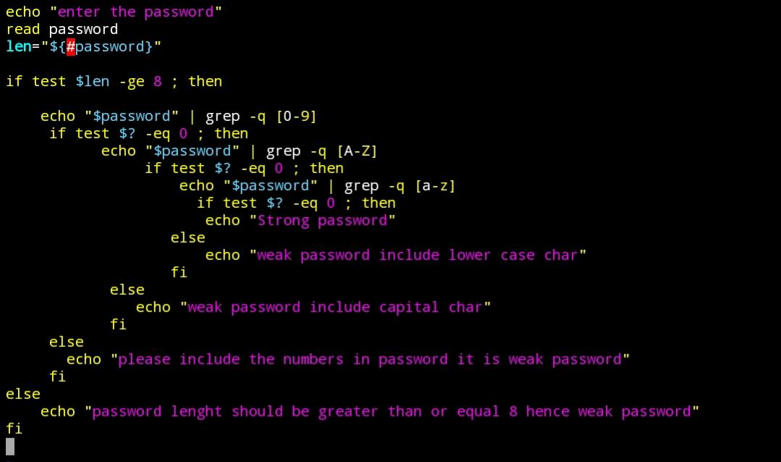

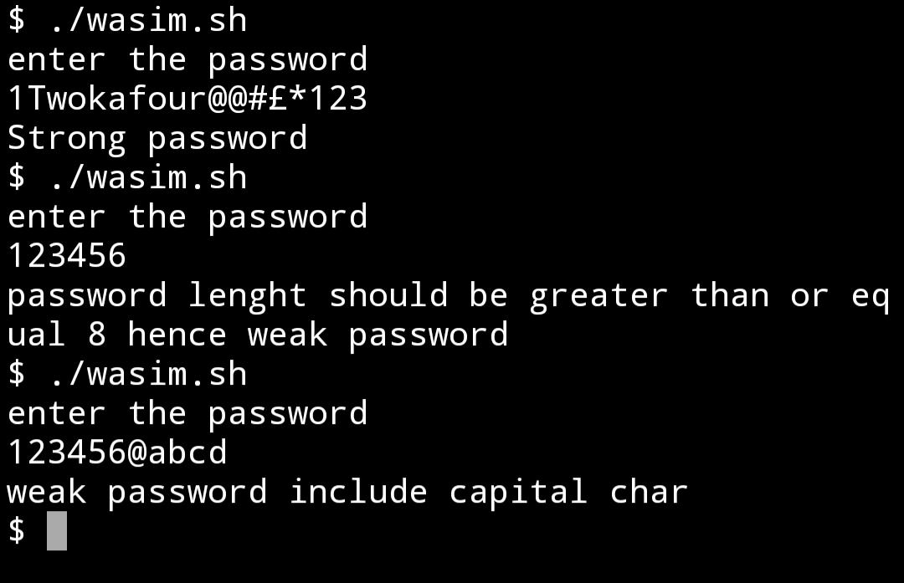Output